# Severn Estuary

Use ASMITA to investigate the impacts of tidal pumping and sea-level rise in the Severn Estuary.

The Severn Estuary is a shallow, funnel shaped estuary, characterised by a very large tidal range and strong tidal currents. On spring tides, the tidal range exceeds 12m (Dyer, 1984), giving the Severn one of the largest tidal ranges in the world. As with most macro-tidal estuaries the action of friction on the tide results in the development of tidal asymmetry and flood dominant transport with distance upstream (Friedrichs and Aubrey 1988, Friedrichs et al, 1998, ABPmer, 2007). The effect of this tidal asymmetry, in combination with settling lag effects (Friedrichs et al, 1998) results in the landward transport of mud in a process often termed “tidal pumping”. This process also applies to sand transport, except that sand transport is more sensitive to the peak values of current speed on the ebb and flood tide and there is thought to be a transport “divide” where the Severn Estuary meets the Bristol Channel, seaward of which the ebb speed dominates and landward of which the flood speed dominates (Culver, 1980, McLaren and Collins, 1989).

# Model Set-up

Set-up a model to qualitatively replicate the large-scale behaviour of Severn Estuary.

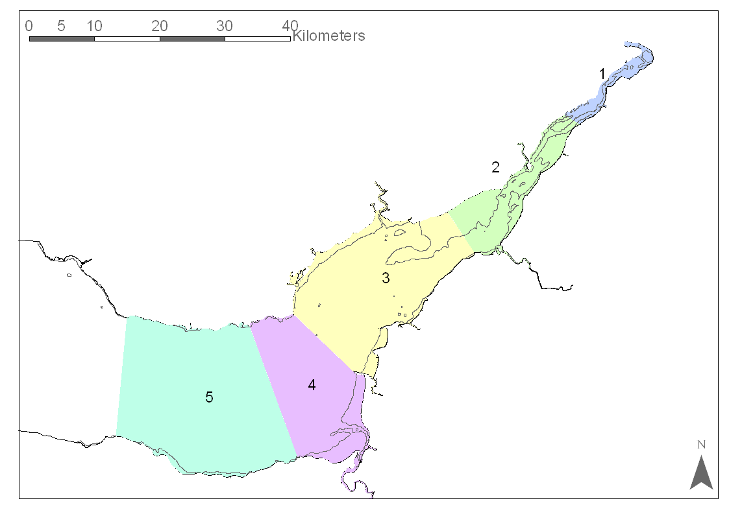

Figure Plan of Severn Estuary showing reaches used for ASMITA modelling. 1=Inner Severn Estuary, 2=Mid Severn Estuary, 3=Outer Severn Estuary, 4=Inner Bristol Channel and 5= Outer Bristol Channel.

## Schematisation

Decide on a schematisation to represent the estuary, bearing in mind that the aim is to study the implications of tidal pumping.

For example, in a previous study, the Severn Estuary and Bristol Channel was schematised as five reaches, each containing a channel and flat element. Reaches one to three are referred to as the inner, mid and outer Severn respectively, Figure 1. Reaches four and five are the inner and outer Bristol Channel. The reaches were defined to match observed discontinuities in the estuary, for example the presence of constraints.

## Baseline

Initial volume and area data will need to be taken from previous studies or from bathymetry and calculations using a GIS. Similarly, data on current speeds and tidal ranges will need to be obtained from Admiralty charts or suitable model outputs.

For the example noted above, the initial volumes and areas used for the baseline model are given in Table 1 and horizontal exchange coefficients are in

Table 2. Volumes were calculated from Seazone bathymetry data of the Severn Estuary using ArcGIS. Data on current speeds and tidal ranges were taken from an existing TIDEWAY numerical model which was used for the Severn Barrage studies in the 1980’s (HR Wallingford, 1981a).

The global equilibrium concentration (ie the average concentration of the open sea at the model boundary) was set to 0.1kg/m3. River flow was set to an average of 300 m3/s (derived from the fluvial data presented in the CHaMP, ABPmer, 2007) with a fluvial concentration of 0.2 kg/m3.

Table 1 Initial volume, area and tidal range data for the baseline model

|  |  |  |  |  |  |  |
| --- | --- | --- | --- | --- | --- | --- |
|  |  |  | Intertidal | | Subtidal | |
| Reach | Tidal range (m) | Length (m) | Area (m2) | Volume (m3) | Area (m2) | Volume (m3) |
| 1 | 8.6 | 19700 | 1.99E+07 | 1.38E+08 | 8.99E+06 | 8.99E+06 |
| 2 | 11.95 | 25000 | 6.33E+07 | 5.81E+08 | 5.56E+07 | 2.65E+08 |
| 3 | 11.415 | 27500 | 6.73E+07 | 5.97E+08 | 3.05E+08 | 2.39E+09 |
| 4 | 10.695 | 11000 | 3.87E+07 | 3.02E+08 | 2.11E+08 | 2.24E+09 |
| 5 | 10.07 | 23500 | 8.16E+06 | 6.65E+07 | 4.91E+08 | 8.24E+09 |

Table 2 Horizontal exchange coefficients for the baseline model

|  |  |  |  |  |  |  |  |  |
| --- | --- | --- | --- | --- | --- | --- | --- | --- |
|  | **u (m/s)** | **H (m)** | **Ws (m/s)** | **ε** | **D** | **A (m2)** | **Lx (m)** | **δ** |
| C1,C2 | 4 | 8.02 | 0.003 | 0.1 | 4275 | 1466 | 22350 | **280** |
| C2,C3 | 2.3 | 12.13 | 0.003 | 0.1 | 2139 | 4756 | 26250 | **387** |
| C3,C4 | 3 | 14.75 | 0.003 | 0.1 | 4425 | 11106 | 19250 | **2553** |
| C4,C5 | 1.8 | 18.90 | 0.003 | 0.1 | 2041 | 19158 | 17250 | **2267** |
| C5,Outside | 2 | 21.83 | 0.003 | 0.1 | 2910 | 20884 | 23500 | **2586** |
| C1, F1 | 0.09 | 6.91 | 0.003 | 1 | 19 | 84710 | 733 | **2179** |
| C2, F2 | 0.23 | 7 | 0.003 | 1 | 120 | 149375 | 2378 | **7538** |
| C3, F3 | 0.22 | 9.46 | 0.003 | 1 | 151 | 156956 | 6776 | **3508** |
| C4, F4 | 0.32 | 9.05 | 0.003 | 1 | 300 | 58823 | 11339 | **1557** |
| C5, F5 | 0.03 | 9.28 | 0.003 | 1 | 3 | 118323 | 10616 | **33** |

Carry out runs to examine the effect of tidal pumping on the representation of the Severn Estuary using the baseline sea-level rise of 2mm/year, with and without tidal pumping. Note that the sea bed of the outer Bristol Channel is largely bedrock and therefore these elements in ASMITA should be prevented from eroding (see Section 5.2.5 of ASMITA manual for details of how to do this).

Then consider two cases of accelerated sea-level rise:

1. An increased rate of sea-level rise at 3.5 mm/year, which is the DEFRA (2006) value for the period 1990 to 2025 and is an intermediate estimate of current levels of sea-level rise given in ABPmer (2007).
2. Examine the implications of an accelerating rate of sea level rise an exponential function was adopted as follows:

*slr(t)=1mm.exp(0.011(t - 1900))* (2)

where t is in calendar years. This provides a rate of 1mm/year prior to 1900, increasing to 3mm/year by 2000, 5.2mm/year by 2050 and 9mm/year by 2100. On this basis the total change from the year 2000 is 0.07m by 2020, 0.2m by 2050 and 0.55m by 2100. (see Section 5.1.2 of ASMITA manual for details of how to do this).

Try to find some data to validate the variation of concentration along the estuary and produce a plot comparing model concentration versus observed. Produce a summary of how this might change under an accelerated rate of sea level rise.

**How does the inclusion of tidal pumping effect the changes in channel and intertidal elements within the model? Does this vary along the estuary?**

ASMITA predicted that the equilibrium concentration in the Severn Estuary would increase slightly upstream, from 0.1 kg/m3 at the mouth to approximately 0.2 kg/m3 in reach one. These concentrations are within the range suggested in the Severn CHaMP sediment budget (ABPmer, 2007) but are at the lower end of this range.

With tidal pumping included, ASMITA predicted that the equilibrium concentration in the Severn Estuary would increase upstream, from 0.1 kg/m3 at the seaward limit of the model to 1.6 kg/m3 within the Severn Estuary. This compares well with data presented in Kirby and Parker (1983), HR Wallingford (1981b), Kirby (1986) and ABPmer (2007).

# References

ABPmer (2007). Severn Estuary Coastal Habitat Management Plan, produced by ABPmer for the Environment Agency.

Culver S J (1980) Differential two-way sediment transport in the Bristol Channel and Severn Estuary, UK, *Marine Geology*, volume 34, ppM39 to M43.

Dyer, K. R. (1984). Sedimentation Processes in the Bristol Channel/Severn Estuary. *Marine Pollution Bulletin*, **15**(2): 53-57.

Friedrichs, C.T., Aubrey, D.G., (1988) Non-linear tidal distortion in shallow well-mixed estuaries: a synthesis, *Estuarine Coastal and Shelf Science*, 27(5), 521-546.

Friedrichs, C T, Armburst, B D and De Swart, H E (1998). Hydrodynamics and Equilibrium Sediment Dynamics of Shallow, Funnel-Shaped Tidal Estuaries. *Physics of Estuaries and Coastal Seas, Rotterdam*.

HR Wallingford (1981a) Severn Tidal Power, Two-dimensional water movement study, HR Wallingford Report EX 985, July 1981.

HR Wallingford (1981b) The Severn Estuary, Observations of tidal currents, salinities and suspended solids concentrations, HR Wallingford Report, EX 966, January 1981.

HR Wallingford (2007) Development of Estuary Morphological Models: Application of ASMITA to the Thames Estuary. HR Wallingford Report TR 162.

HR Wallingford (2008) Application of ASMITA to model the possible effects of managed realignments on the morphology of the Thames Estuary, Technical Note 01, Release 4, Appendix B, IN: *Thames Estuary 2100, The morphological development of the Thames Estuary, An assessment of the impacts of managed realignment on the morphological evolution of the Thames Estuary*, HR Wallingford Report EX5901, prepared by HR Wallingford and ABPmer for the Environment Agency, October 2008.

Kirby R and Parker W R (1983) Distribution and behaviour in the Severn Estuary and Inner Bristol Channel, UK, *Canadian Journal of Fisheries and Aquatic Sciences*, Volume 40, Supplement Number 1, pp83-95.

Kirby R (1986) Suspended fine cohesive sediment in the Severn Estuary and Inner Bristol Channel, UK Department of Energy, Energy Technology Support Unit, Report ETSU-STP-4042.

Kragtwijk NG, Stive MJF, Wang ZB, Zitman TJ (2004) Morphological response of tidal basins to human interventions, Coastal Engineering, 51, 207-221.

McLaren P and Collins M B (1989) Severn Barrage Development Project, Sediment Transport Pathways in the Severn Estuary and Bristol Channel, Working Document Reference STPG/GEOSEA/3.1 (iii)f, March 1989.

Stive, M. J. F., Wang, Z. B., Capobianco, M., Ruol, P., and Buijsman, M. C. (1998).

Morphodynamics of a tidal lagoon and the adjacent coast. In Dronkers and Schef-

fers, editors, *Physics of Estuaries and Coastal Seas*, pages 397-407, Rotterdam.

Balkema.

van Goor, M. A., Zitman, T. J., Wang, Z. B., and Stive, M. J. F. (2003). Impact

of sea-level rise on the morphological equilibrium state of tidal inlets. *Marine*

*Geology*, **202**:211-227.